Contents

Portfolio 1.1 ----------------------------------------------------------------------------------- 2

Portfolio 1.2 ----------------------------------------------------------------------------------- 3

Portfolio 1.3 ----------------------------------------------------------------------------------- 4

Portfolio 1.4 ----------------------------------------------------------------------------------- 5

Portfolio 1.5----------------------------------------------------------------------------------- 6

Portfolio 1.6 -----------------------------------------------------------------------------------

# Portfolio 1.1

**Project Proposal**

**Site Title**: House of Cards

**Developer**:

The role of the developer is to design the website that shows various information of cards and display on home screen. And also develop according to the standards and run in most common web browsers.

**Rationale or Focus of the Project:**

The House of cards site should be accessible to all users with different browsers and display the necessary information placed on the website without and accessibility or user interface issues.

**Planning the site:**

Main Elements of the Site:

* Logo on each page
* Navigation from page to page (multi-page links)
* Accessibility features
* Modern browsers compatibility

Content:

Estimated number of pages range from 20-25 including descriptive pages

Target of audience:

The typical audience for this site are those who would like to know more about the business of house of cards and details of the shop

Design Considerations:

* Run in all browsers
* Have accessibility features
* Simpler navigation
* Should be developed using basic HTML and CSS

Limiting factors:

* No scripting can be used
* No third part libraries or rapid development tools can be used in developing the site
* Third party plugins or softwares must not be used to design any part of the application

**Portfolio 1.2:**

**Home page:**

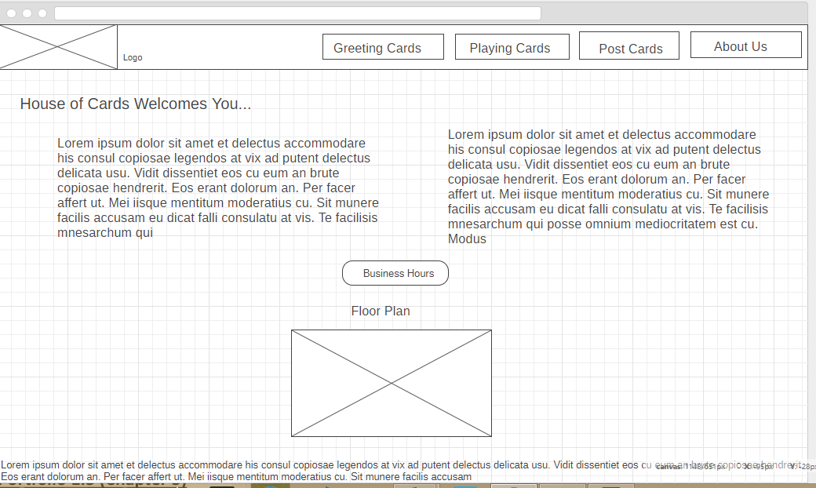

Figure: Welcome page/index page

**Cards Page:**

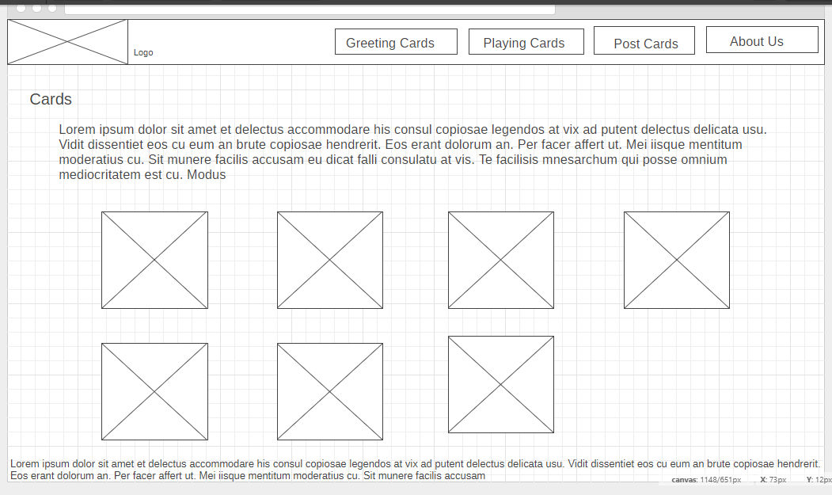

Descriptions page:

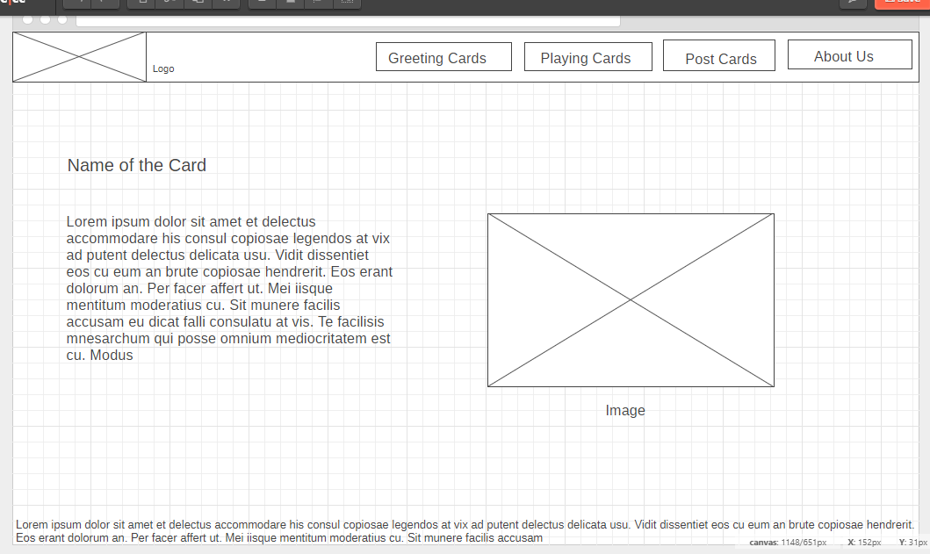

Figure: Individual pages

**Portfolio 1.3**

**Website Specification:**

**Client**: House of Cards

**Specification**:

* Every page on the site must contain logo and navigation
* Multi-page navigation from all the pages
* No images should be edited, but can be resized or cropped
* Opening hours of the business should be displayed in a separate web page when clicked on a link
* Provide as much information as possible in the website
* Names must not be modified or changed in any manner

**Success Measurement:**

* Visitors should be easily navigate and find the information on the website without getting lost
* Satisfied user content and experience
* Increase the business in terms of monetary and fame
* Provide information about the business online, always

**Mission**:

Mission is to develop the house of Cards website and increase the offline business.

Target Audience:

All persons who have the basic knowledge of browsing the internet would be sufficiently able to get the information form the site.

Technical Limitations for Developing:

1. No scripting can be used
2. Only static content is shown i.e. the site is entirely designed in HTML and CSS

Flow Chart

**Index page**

Playing Card

Post Cards

Greeting Cards

About Us

OpenHours

Floor Map

Application Flow:

1. All pages are connected through navigation bar
2. User can navigate from any page to index or home page by clicking on the brand name or logo

This structure is chosen to ease the navigation from page to page and visitor can easily find information about and of the item on the site with a single click rather than going to home page and traversing to the required page

Portfolio 1.4

Site Design:

1. Design of the site is done with cascading style sheets linked externally on each page
2. All styles are written in a single stylesheet and referenced in the header of each html document
3. These styles are applied using class names and ids
4. General elements are styles globally with name of the element itself

**Different Sections in the HTML Document:**

The document that is to be designed will have three sections, namely:

1. Head Section

* Congaing links to stylesheets
* Meta tags
* Title of the page

E.g.:

<head>

<links and tags>

<title>title of the page</title>

<nav>M</nav>

</head>

**Body Section**

1. Body section is divided into many sections and blocks, each of these blocks have their own class names for styling and aligning it on the web page
2. Contains brief information of the menu and items selected

Body {

* List of items
* Sections
* Links
* Maps

}

**Footer**:

* Footer text contains copyright information of the website and legal terms and conditions to use the content in the web pages

**Portfolio 1.5:**

**Headings and Typography:**

1. There are 6 heading tags from h1 to h6 , which are used to increase the boldness of the text and title
2. Font size properties are used in CSS to increase the default sizes and weights
3. Some texts and dummy paragraphs uses times new roman and some text on the web pages uses default typography and no third part links or styles are used

Hyperlinks:

1. Hyperlinks are customizes using css properties
2. Default text decoration is removed for almost all hyper links
3. Padding is added to all a tags
4. Hover effects are added when about to be clicked

* To make the text and paragraph readable to any kind of users line height is increased and enough spacing I added to read it easily
* Margins and padding are added according to the initial design

**Portfolio 1.6**

* Box model gives the advantage to arrange the items and elements on the web page accordingly
* In the application designed navigation, logo, body section, footer class uses this box model

Box model without proper margins and paddings

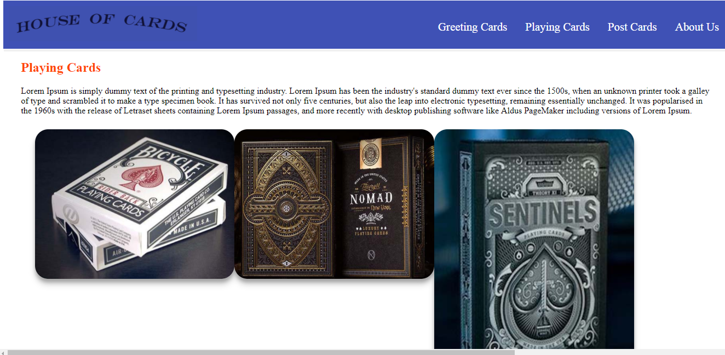

Figure: Box model demo (Before)

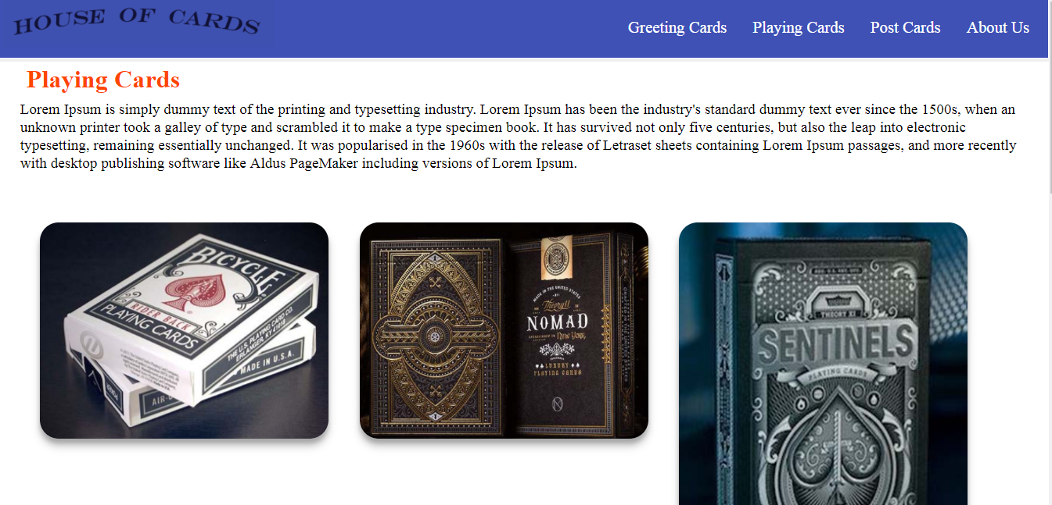

Figure: Box model demo (after)

* This application completely takes advantages of box model and structured in a required way using paddings, margins etc.